./

|  |  |  |  |  |  |
| --- | --- | --- | --- | --- | --- |
| **Ver.Rel. No.** | **Release Date** | **Prepared. By** | **Reviewed By** | **Approved By** | **Remarks/Revision Details** |
|  | 20/2/2022 | Allen Wilson G |  |  |  |
|  |  |  |  |  |  |
|  |  |  |  |  |  |
|  |  |  |  |  |  |
|  |  |  |  |  |  |

**Document History**

**Table of Contents**

|  |  |  |
| --- | --- | --- |
| **Chapter No** | Tittle | **Page No** |
| **1.** | **Requirements and Analysis**   1. Empathize & research 2. High-Level Requirement 3. Low-Level Requirement 4. SWOT Analysis 5. 5W 1H | **2** |
| **2.** | **Design**   1. Block Diagram 2. Structural diagram | **4** |
| **3.** | **Summary** | **7** |

**Case Study of Home security system**

1. **Requirements:**
2. **Empathize** **Research:**

Smart Home automation is a process for improving the quality of resident’s life by facilitating a flexible, comfortable and secure environment. Home security system is the most prominent feature for home automation. Traditional techniques of alarm based security have gained much popularity in past decades. PIC18F452 microcontroller based home security system has been designed without GSM technology. Here, ATMEGA16 microcontroller based home security system with GSM technology has been described. In addition, Bluetooth application has been used to control the system. Consequently, the proposed system provides reliable security within reasonable cost and also removes the circuit complexity.

**Analysis:**

**3 months to 5 months**

1. **High-Level Requirement:**

|  |  |
| --- | --- |
| **ID** | **Decryption** |
| HR01 | SMS Display to mobile phone |
| HR02 | Buzzer alarm |
| HR03 | LCD display |
| HR04 | GSM module |
|  |  |

1. **Low-Level Requirement:**

|  |  |
| --- | --- |
| **ID** | **Description** |
| LR01 | Pressure sensor for door |
| LR02 | Pressure sensor of window |
| LR03 | Password from keypad |
| LR04 | Password from mobile phone |

1. **SWOT Analysis:**
2. **5W 1H:**

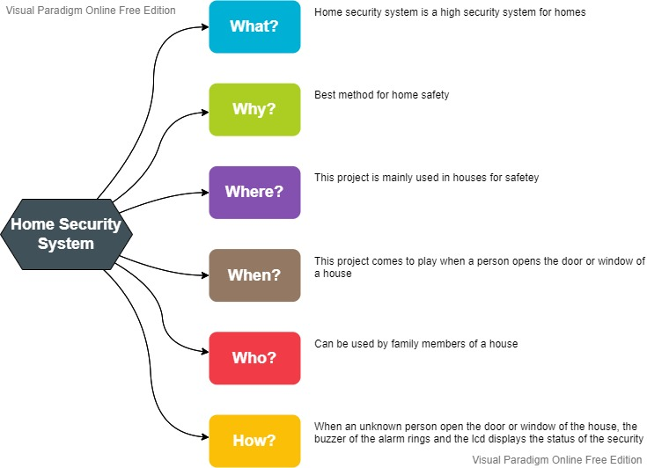

1. **Design:**
2. **Block Diagrams:**

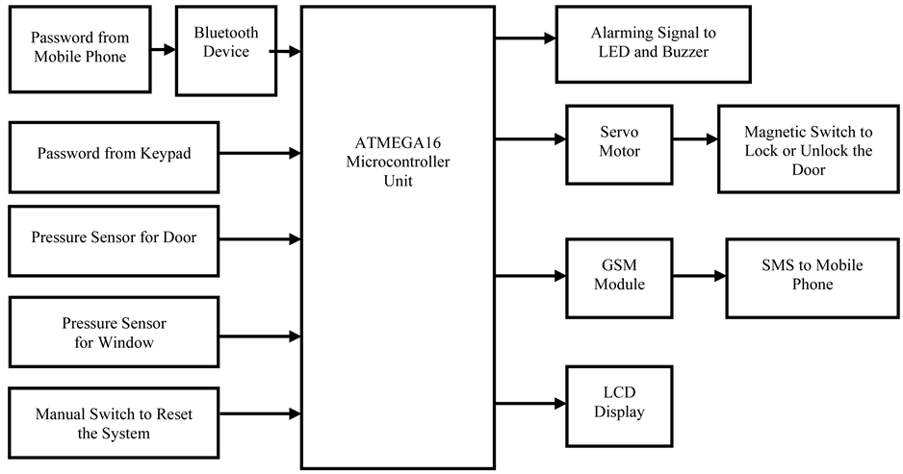

1. **Structural Diagram:**

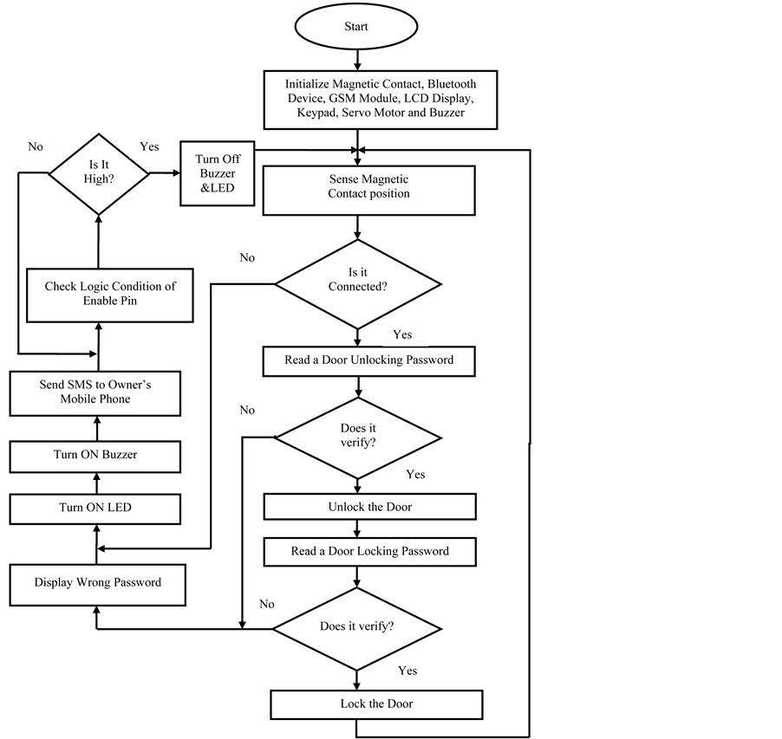

1. **Summary:**

The system is intelligent enough to monitor the secure environment. In addition, the user is informed about the security breach through GSM network that provides a special opportunity whenever the user stays at far away from home. However, Android application is the most stunning feature in order to control the system through a Bluetooth device. Moreover, the system provides the reliable operation within reasonable cost and removes the system complexity. In this work, traditional burglar alarm mode, LED lights and LCD are the promising features used to ensure reliability. The whole system is implemented on a practical home security system which requires considerable effort to install it. Consequently, the system is also applicable for commercial purposes due to versatile ways of security and controllability.

1. **REFERCES**
2. Rana, G.M.S.M., Khan, A.A.M., Hoque, M.N. and Mitul, A.F. (2013) Design and Implementation of a GSM Based Remote Home Security and Appliance Control System. Proceedings of the 2nd International Conference on Advances in Electrical Engineering, Dhaka, 19-21 December 2013, 291-295.

[2] Islam, M.S. (2014) Home Security System Based on PIC18F452 Microcontroller. Proceedings of 2014 IEEE International Conference on Electro/Information Technology, Milwaukee, 5-7 June 2014, 202-205.

[3] Golzar, M.G. and Tajozzakerin, H.R. (2010) A New Intelligent Remote Control System for Home Automation and Reduce Energy Consumption. 4th Asia International Conference on Mathematical/Analytical Modelling and Computer Simulation, Kota Kinabalu, 26-28 May 2010, 174-180.

# 